**Mrs. Glover Phone:** 706-823-6933

**Website:** <https://www.rcboe.org/site/Default.aspx?PageID=3347>

**Canvas:** <https://rcboe.instructure.com/>

**Email:** [gloveam@boe.richmond.k12.ga.us](mailto:gloveam@boe.richmond.k12.ga.us)

**Course Description**

AP Biology is a year long course designed to be taken by students after the successful completion of both high school biology and chemistry. AP Biology includes those topics regularly covered in a college introductory biology course and differs significantly from the standards-based, high school biology course with respect to the kind of textbook used, the range and depth of topics covered, the kind of laboratory work performed by students, and the time and effort required of the students. The textbook used by AP Biology is also used by college biology majors and the kinds of labs done by AP students are equivalent to those done by college students. AP Biology is a course that aims to provide students with the conceptual framework, factual knowledge, and analytical skills necessary to deal critically with the rapidly changing science of biology. This course is designed to prepare students for the Biology College Board Advanced Placement Exam.

**General Information**

* **Supplies...**students will need their computer, textbook (Biology, Mader and Windelspecht, 12th ed. (2016) from McGraw Hill Education [Replacement Price: $137.97]), writing utensils, paper, graph paper, a scientific calculator, colored pencils, and highlighters. A three ring binder with 10 dividers is suggested for class. Many of these items are provided in the classroom, but students may want their own or need them at home. Special projects may require additional supplies that may be maintained at home.
* **Tutoring...**after school Monday-Wednesday, students schedule independently.
* **Make-up work...** assignments will be available in Canvas so students can stay caught up with the class in case of absences.

**CLASS RULES**

Be in your seat ready to learn when the bell rings (room 812). Your supplies should be on your desk. You will not be allowed to leave after the bell rings(you will receive emergency passes each semester to leave the room)**.** Respect everyone in the classroom. Do not speak unless you have raised your hand and have been called on. Do not get out of your seat unless you have been given permission. Do not touch anything or anyone unless you have been given permission. Work hard. Give 100% effort as much as possible. Academic dishonesty will result in a zero.  
  
**CONSEQUENCES**

1st offense- verbal warning   
2nd offense- time out (seat change, step outside to talk, or go to teacher next door) and/or student essay  
3rd offense- detention & contact parents  
4th offense- referral to office  
**\*I reserve the right to assign detention or immediately refer students to the office for serious offenses!**

**Grading**  
Grades are accessible on the school website through Infinite Campus (IC). The following categories will be used to determine a preliminary semester grade which will then be used with the semester final exam grade to comprise the semester grade for the class:

* 60% - Minor assignments: these types of assignments are intended to measure student progress toward mastery. These assignments are still assessing mastery of content but only small segments that ultimately all fit together within one module. Students should show positive growth in knowledge of the content. (quizzes, most labs, in-class work, homework)
* 40% - Major assignments: these types of assignments can be extensive and are intended for students to demonstrate mastery of all content in the current module. These assignments can be lengthy and require dedicated preparation. (tests, formal reports, major projects)

#### A culminating mock final exam will be administered at the end of each semester. The semester grade calculated above will count as 80% of the semester grade and the final exam will be 20% of the semester grade. This is the opportunity for students to demonstrate their critical thinking skills by analyzing and interpreting content from the entire semester then synthesizing original thoughts/ideas/opinions relevant to the content.

#### 

#### Example calculations: (77 * 0.6) + (74 * 0.4) = 75.8 for the preliminary semester grade

#### (75.8 * 0.8) + (78 * 0.2) = 76 for the final semester grade

#### Late work is usually accepted until the end of the month or unit through Canvas. Once the work is locked, it will NOT be reopened. Academic dishonesty will result in the student receiving NO CREDIT for that graded item and will, therefore, be required to complete an alternate assignment at the discretion of the teacher.

**Labs**

You will spend a minimum of 25% of instructional time engaged in inquiry-based laboratory work. You will report your lab findings in various ways, including through formal reports, presentations with visuals, and group discussions. We will also be working on case studies and modeling exercises to reinforce learning. Many of our labs are done as a team effort. Everyone is responsible for their part. However, this does not mean that labs are directly copied from team members. Data is shared but analysis is an individual effort. If you miss a lab, you may be required to view it online and write a paper on it.

**Exams**

At the end of each unit, an exam will be given, which is a combination of multiple choice and free response FRQ). Unit exams may take two class periods and testing time for these exams will be limited just as it is for the AP Biology Exam. There will be a comprehensive final exam at the end of each semester. The AP Biology exam is scheduled for Thursday, May 16, 2024 at 12:00 PM. The second semester exam will be given before this date so that it may be reviewed before the College Board AP Biology exam.

**Topic Outline For The Year**

The AP Biology Curriculum is framed around four Big Ideas. For each of these Big Ideas, there is a set of core concepts called Enduring Understanding, which will be used to guide the AP Biology course curriculum. Below is an outline of the AP Biology Curriculum Big Ideas and the Enduring Understandings topics covered in this course. The year will be divided into eight units. Below is a chart with the percentage of each unit on the test. AP Biology is a rigorous course that demands personal responsibility from the student. In order for students to plan effectively, they are provided with due dates for all major projects, labs and tests. They are strongly encouraged to complete nightly readings and study each day’s lecture notes on their own time.

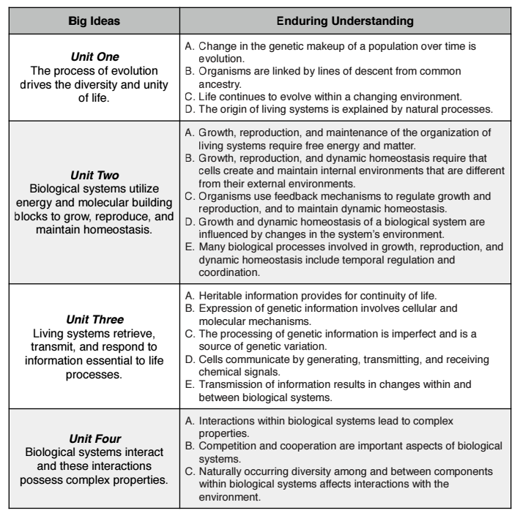

|  |  |
| --- | --- |
| **Unit** | **Exam Weighting (Multiple-Choice Section)** |
| **Unit 1: Chemistry of Life** | 8%–11% |
| **Unit 2: Cell Structure and Function** | 10%–13% |
| **Unit 3: Cellular Energetics** | 12%–16% |
| **Unit 4: Cell Communication and Cell Cycle** | 10%–15% |
| **Unit 5: Heredity** | 8%–11% |
| **Unit 6: Gene Expression and Regulation** | 12%–16% |
| **Unit 7: Natural Selection** | 13%–20% |
| **Unit 8: Ecology** | 10%–15% |

**Science Practices**

|  |  |  |
| --- | --- | --- |
| **Skill** | **Description** | **Exam Weighting (Multiple-Choice Section)** |
| **1. Concept Explanation** | Explain biological concepts, processes, and models presented in written format | 25%–33% |
| **2. Visual Representations** | Analyze visual representations of biological concepts and processes | 16%–24% |
| **3. Question and Method** | Determine scientific question and method | 8%–14% |
| **4. Representing and Describing Data** | Represent and describe data | 8%–14% |
| **5. Statistical Tests and Data Analysis** | Perform statistical tests and mathematical calculations to analyze and interpret data | 8%–14% |
| **6. Argumentation** | Develop and justify scientific arguments using evidence | 20%–26% |

**Study Guide (How to Study)**

*A biology textbook cannot be read the way you would read a novel.* Begin by pre-reading the chapter; glance at the section headings, charts and tables in order to organize the material in your mind and stimulate your curiosity. This will make it easier to read the chapter and extract more information from it.  
  
 *Realize that reading is not studying.* Reading is a form of passive learning which is the least efficient and least effective way for most people to learn. (Listening is another form of passive learning.) Active learning involves reprocessing and using the information in some way and is a much more efficient and effective way to learn. To turn passive reading of the text into active learning, stop frequently (at least every paragraph) and consider what you have just read. What is the concept being discussed? Put it in your own words (out loud or by writing it down); by doing so you are reprocessing and using the information presented in the text. Place a few key notes in the book's margin; make sure these notes include all new terms and illustrative examples. If there is not enough room in the margins to write, use "post-its" for making your notes. (Extensive high-lighting of your text does not constitute active learning and generally is a waste of time. The author has usually already put the key words in bold print.)

*Taking lecture notes is a form of active learning if done properly.* Simply writing down what is written on the board is passive learning (it's a start, but is not as effective as it could be). To get the most out of taking lecture notes, do it in a systematic manner. Before class read the textbook material to be covered in lecture. You will then use class time more efficiently because you will learn more from the lecture, and you will be able to take better notes having been introduced to many of the concepts in the text. During lecture do not attempt to write down every word that is said; that approach is futile and unnecessary. Instead, focus on the major ideas. Once you understand a point that is being made, write it down in your own words (i.e. practice active learning), making sure to include any new terms, illustrative examples, diagrams, or lists which may be given. Leave three inches on the left hand side of your page so that you can add notes after class to amplify the major points of each lecture as well as fill in gaps and add relevant information from the textbook or lab manual. For best results this should be done before the next lecture. Simply rewriting lecture notes word for word is not active learning.  
  
 *If you don't come to class, you will have to rely on other student's notes* to obtain a brief overview of what was said (those notes often only contain what was written on the board and sometimes contain errors -- even notes taken by "A" students). Most of you will be able to follow the lectures; that is, the presentation will make sense to you as it is given. Don't be fooled, however, into believing that being able to follow a lecture constitutes understanding the material well enough to answer questions on the exam. It will be necessary for you to actually study the lecture content (hopefully while it is still fresh in your mind) for you to be able to use that information during the exam. Some of the questions on exams require that you combine (integrate) information from two sources to arrive at the answer; in other questions you will have to apply information you have learned to a new situation. In other words, just memorizing the material is not enough to do well on exams; you will need to understand the material so you can use and/or apply it. Here are two examples. In one lecture you learned that membranes are composed of phospholipids; in another lecture you learned that chloroplasts contain membranous thylakoids. You might be asked to integrate this information and recognize that chloroplasts contain more phospholipids than do ribosomes, the nucleolus or the cell wall. In another example, you learned that the Golgi complex functions to package materials for export from the cell. You might be asked to apply this information to a new situation by recognizing that a nectar secreting cell in a flower would have a very active Golgi complex (rather than a very active mitochondrion, chloroplast, nucleus or vacuole).  
  
 *Lecturers frequently approach a subject by presenting the "big picture" first* -- explaining the what and the why of the subject, then subsequently presenting the details, the how, of the subject. In your studying you should use this same approach. Start out by making sure you understand the big picture and then study the details which should help you understand and remember the big picture. The objective here is to understand the material, not simply memorize it. If you understand something, you can relate it to other knowledge you have, you can apply it to new situations (including exam questions) and you will find that it is easier to remember the material because it "makes sense". Something you have memorized is often harder to remember because it doesn't "make sense".  
  
 *Summarize information by making your own diagrams and tables which will allow you to rehearse and test yourself on the material.* Rehearsal and self-testing are crucial steps in the active learning process. For example, sketch out the life cycle of a moss from memory, labeling the stages (gametophyte, sporophyte), structures (sporangium, eggs, sperm) and processes (fertilization, meiosis). Write down the summary reaction for photosynthesis from memory and describe what happens to carbon, energy, electrons and oxygen during photosynthesis.  
  
 *Relate new information to other, related information* -- For example, it is especially useful to be able to place organisms in their proper phylogenetic (evolutionary) relationships and to relate structure and function. In other words, it is easier to remember the characteristics of an organism if you remember the characteristics of its ancestors and close relatives. It is easier to remember the structure of a molecule, cell or an organ if you can also remember something about the function of that molecule, cell or organ. As you study, ask yourself "How does this fit in with what I already know?" "Does it make sense?" Compare and contrast exercises are especially helpful in identifying relationships you may not have noticed before -- "In what way is it similar to or different from a similar process or structure?"  
  
 *Study with a friend in the class.* Take turns explaining the material to each other. Explain a concept, process, or life cycle as a story that unfolds logically from point A to point B to point C etc. with one event or item leading naturally to the next, just as they would in a story. Verbalizing the material is one of the best forms of active learning because it forces you to organize it in your own mind and helps you remember it. Teaching a subject is the best way to learn it -- ask any teacher.  
 Take advantage of the pictures and figures in the text (a picture is worth a thousand words). Some of these illustrations will be covered in lecture and you will be expected to understand the concept being illustrated. Exams may include figures to analyze.  
  
 *There is too much new material in a biology class to be able to learn two weeks' worth of material the night before an exam.* New terms are introduced faster in biology courses than in foreign language courses. You must keep up. Interact with the course material on a daily basis; learn the new words, concepts, phylogenetic relationships, structures and their functions. Review your text material and lecture notes daily so that you can avoid cramming at test time. Daily studying and rehearsal helps get information into long-term memory.  
  
 *Make the most of your time in lab by arriving fully prepared.* Preparation includes reviewing the lab exercise on your own -- "What can I expect to learn from this activity?" "How will I be doing this experiment?" "What do I expect the results of this experiment to be?" If you approach lab as a learning experience rather than as something to finish as soon as possible, you will find that you are being exposed to much of the same material covered in lecture, but in another framework. By learning it in lab, you will have to spend less time studying on your own.

**\*There will be a form in the student’s Canvas assignments for them and their parent/guardian to place their initials in to acknowledge that this document and lab safety info from Canvas have been read.**